EXPERIMENT 3

DML COMMANDS-INSERT,SELECT

**OUT PUT**

1)

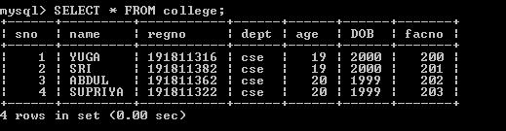

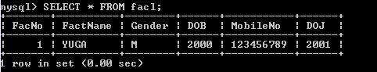

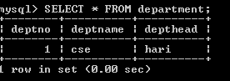

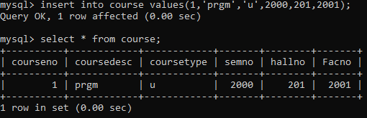

2)



3)

